Name: Nihaal K Zaheer
Section: 2
University ID: 105254206

Lab 2 Report

Summary:

Lab Questions:

3.1:
6pts In the report, include the relevant lines from “ps -l” for your programs, and point out the following items:
- output
- process name
- process state (decode the letter!)
- process ID (PID)
- parent process ID (PPID)
2pts Repeat this experiment and observe what changes and doesn't change.
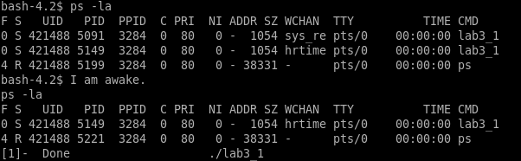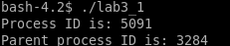
- Output – it gives the current processes running (running, sleeping and zombie), ps -el would give all processes, even those that have already been terminated.

- process name - lab3_1
- process state (decode the letter!) : S (Sleeping)
- process ID (PID) : 5091
- parent process ID (PPID) : 3284

2pts Find out the name of the process that started your programs. What is it, and what does it do?
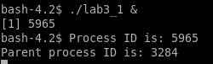
Process ID (PID) changes
Parent Process ID (PPID) stays the same
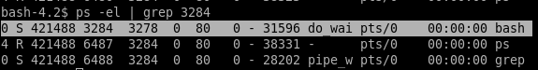
When we search up the PID of the parent process, we find out that the Process name is bash.
Bash is the shell we use. It is the command processor that runs in a text window.
It also reads and executes commands.
3.2:
1pt Include the output from the program
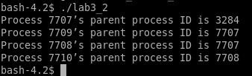

4pts Draw the process tree (label processes with PIDs)
3pts Explain how the tree was built in terms of the program code

2pts Explain what happens when the sleep statement is removed. You should see processes reporting a parent PID of 1. Redirecting output to a file may interfere with this, and you may need to run the program multiple times to see it happen.
The main/ the program has the PID 7707, when we call the fork() function,
it makes a new process 7708. Now on calling fork() again, it is executed on both the parent and the child, so it makes 2 new process statements(forks), one from the parent(7709) and the other from the child (7710). These in-turn runs the rest of the code, that is, usleep, printf and sleep(2).
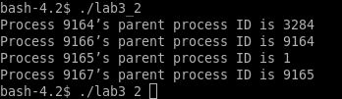
When the sleep commands are removed, the fork doesn’t have enough time to build the tree, but creates a fork by default. Since it doesn’t have enough time to build, it makes a fork with PID 1 as it’s parent.

3.3:
2pts Include the (completed) program and its output
4pts Speculate why it might be useful to have fork return different values to the parent and child. What advantage does returning the child's PID have?
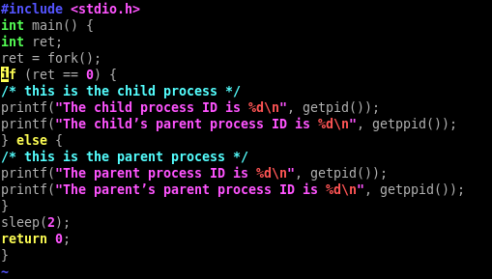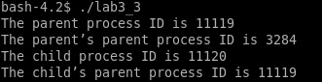

If for returned the same value for child and parent processes, we cannot differentiate between the 2.
Let’s say we want to kill the child process, and let the parent process run. This would not be possible if they both had the same PID.
Since there isn’t a function that returns the child’s PID, like how we have the PPID that returns the parent’s PID, returning the child’s PID would be useful.
3.4:
2pts Include small (but relevant) sections of the output
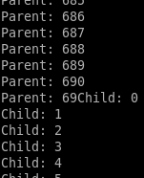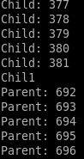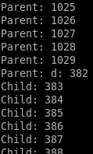

4pts Make some observations about time slicing. Can you find any output that appears to have been cut off? Are there any missing parts? What's going on (mention the kernel scheduler)?
We see that the output keeps switching between the Parent process and child processes. This is handled by the kernel scheduler.
We see that the output gets cutoff as it switches between processes. In the first instance, when the parent is at 690 it switches to the child process, but the 0 in 690 gets cutoff and is overwritten with the child process.
We see several instances of the similar discrepancies consistently upon switching.

3.5:
6pts Explain the major difference between this experiment and experiment 4.
Be sure to look up what wait does (man 2 wait).

3.6:
2pts The program appears to have an infinite loop. Why does it stop?
4pts From the definitions of sleep and usleep, what do you expect the child's count

to be just before it ends?
2pts Why doesn't the child reach this count before it terminates?

3.7:
8pts Read the man page for execl and relatives (man 3 exec). Under what conditions is the printf statement executed? Why isn't it always executed?
(consider what would happen if you changed the program to execute something other than /bin/ls.)

3.8:
2pts What is the range of values returned from the child process?
2pts What is the range of values sent by child process and captured by the parent process?

2pts When do you think the return value would be useful?

Hint: look at the commands true and false.

